SESSION 1 LAB EXPERIMENT
EXP 6 : Sort and Find Maximum
#include <stdio.h>

void swap(int *a, int *b)
{
int temp = *a;
*a = *b;
*b = temp;
}

int partition(int arr[], int low, int high)
{
int pivot = arr[high];
int i = low - 1;

for (int j = low; j < high; j++)
{
if (arr[j] < pivot)
{
i++;
swap(&arr[i], &arr[j]);
}
}

swap(&arr[i + 1], &arr[high]);

return i + 1;
}

void quickSort(int arr[], int low, int high)
{
if (low < high)
{
int p = partition(arr, low, high);

quickSort(arr, low, p - 1);
quickSort(arr, p + 1, high);
}
}

int main()
{
int n;
int arr[100];

printf("Enter size of array: ");
scanf("%d", &n);

if (n == 0)
{
printf("List is empty\n");
return 0;
}
printf("Enter array elements:\n");
for (int i = 0; i < n; i++)
{
scanf("%d", &arr[i]);
}
quickSort(arr, 0, n - 1);
printf("Sorted array: ");
for (int i = 0; i < n; i++)
{
printf("%d ", arr[i]);
}
printf("\nMaximum element = %d\n", arr[n - 1]);
return 0;
}
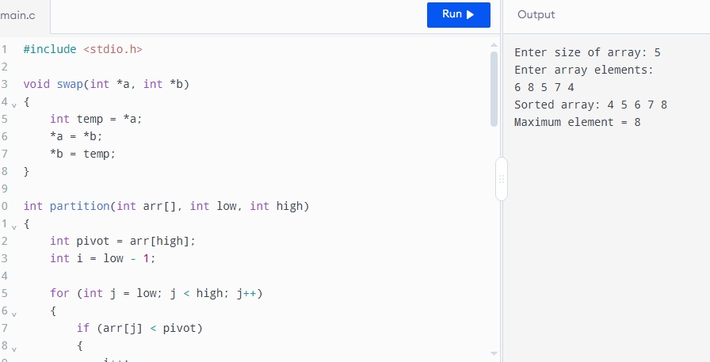
Average Time Complexity: O(n log n)

